**AI-Powered Skin Condition and Issues Detection**

Presented by:

Almoatasembellah Aboubakr Jafer Mohamed

Ahmed Ismail El Sayed El Sayed Azzam

Mohamed Sameh Ahmed

Toka Magdy Fekry  
Haya Mohamed Mahmoud  
Ann Michel Yacoub  
  
Instructor: Eng. Abdelrahman ElMashtoly

Table of Contents

**1. Introduction** 4

**1.1** **Problem Statement** 4

**1.2 Project Objectives** 4

**1.3 System Components** 5

**1.4** **Contribution & Motivation** 6

**1.5** **Project Workflow Summary** 6

**2. Project Planning** 6

**2.1 Scope** 6

**2.2 Objectives** 7

**2.3 Deliverables** 7

**2.4 Out-of-Scope Items** 8

**2.5 Project Workflow Diagram** 8

**3. Stakeholder Analysis** 9

**3.1 Stakeholder Identification** 9

**3.2 Stakeholder Influence on Project Design** 9

**3.3 Summary** 10

**4. Data Collection, Preprocessing & Exploration** 10

**4.1 Data Sources** 10

**4.2 Dataset Description** 10

**4.3 Preprocessing Pipeline** 11

**4.4 Exploratory Data Analysis (EDA)** 12

**4.4.1 Data Split Distribution Analysis** 12

**4.4.2 Visual Sample Inspection** 13

**4.4.3 Augmentation Preview** 14

**5. Image Classification Model Development** 15

**5.1 Custom Convolutional Neural Network (CNN) Architecture** 15

**5.2 Training Strategy and Model Calibration** 15

**5.3 Model Performance and Evaluation** 16

**5.3.1 Training Dynamics** 16

**5.3.2 Quantitative Performance Metrics** 17

**5.3.3 Confusion Matrix Analysis** 17

**5.3.4 Qualitative Prediction Samples** 18

**6. Advanced Techniques & Transfer Learning** 19

**6.1 Rationale for Transfer Learning** 19

**6.2 VGG16-Based Model Architecture and Fine-Tuning** 19

**6.3 Comparative Model Performance** 20

**6.4 Impact and Conclusion of Transfer Learning** 21

**7. Chatbot Development (RAG + Mistral LLM)** 21

**7.1 Purpose and Design Philosophy** 21

**7.2 Knowledge Base Construction** 22

**7.3 Retrieval-Augmented Generation (RAG) Pipeline** 22

**7.4 Architectural Components** 23

**7.5 System Integration** 23

**8. Web Application (Streamlit Interface)** 24

**8.1 Design Philosophy and User Experience (UX** 24

**8.2 Application Interface and Workflow** 24

**8.3 Technical Implementation Highlights** 25

**8.4 User Interface Visual Representation** 26

**9. Challenges & Solutions** 29

**9.1 Data-Related Challenges** 29

**9.2 Model Development Challenges** 29

**9.4 Summary** 30

**10. Conclusion and Future Work** 30

**10.1 Project Conclusion** 30

**10.2 Future Work and Enhancements** 31

# **1. Introduction**

Skin diseases are among the most common health concerns worldwide, yet many individuals lack access to dermatologists or reliable medical advice. Early detection and correct classification of skin issues can significantly improve treatment outcomes and prevent worsening conditions.

This project presents a Skin Issue Detection and Recommendation System that uses deeplearning, transfer learning, and LLM-powered chatbot technology to automatically classify common skin issues and provide tailored skincare advice.

The goal of the system is to create an accessible, user-friendly platform where users can upload a skin image, receive a condition prediction, and get guidance through an intelligent skincare chatbot. The entire system is deployed through an interactive Streamlit web interface, making it easy for non-expert users to access.

## **Problem Statement**

Dermatological resources are limited in many regions, and patients often delay treatment due to lack of awareness or hesitation. Manual evaluation is time-consuming and subjective.

Key problems addressed:

* Lack of accessible dermatological diagnosis tools
* Difficulty distinguishing between common skin issues (acne vs pores vs dark spots, etc.)
* Need for personalized skincare advice based on the detected condition
* Integration of AI models into a smooth user interface for real-time feedback

## **1.2 Project Objectives**

This project aims to:

1. **Build a robust image classification model** capable of detecting:
   * Acne
   * Blackheads
   * Dark Spots
   * Wrinkles
   * Enlarged Pores
2. **Develop a transfer learning model** (VGG16) to compare performance and improve accuracy.
3. **Create an intelligent skincare chatbot** using:
   * FAISS vector database
   * Sentence Transformer embeddings
   * Mistral-7B LLM
4. **Integrate the models into a single web app** using Streamlit for:
   * Image upload
   * Skin issue detection
   * Skincare product and routine recommendations

## **1.3 System Components**

1. **Image Classification Model (CNN)**

A custom-built Convolutional Neural Network with 102M parameters trained on 9,770 balanced images.

1. **Transfer Learning Model (VGG16)**

A fine-tuned VGG16 model achieving 95% test accuracy.

1. **Skincare Chatbot**

A retrieval-augmented chatbot combining:

* Custom CSV knowledge base
* FAISS vector store
* Mistral-7B Instruct model

1. **Streamlit Web Interface**

A clean user interface allowing:

* Image upload
* Model prediction output
* Chatbot Q&A interaction

## **Contribution & Motivation**

This project combines computer vision, natural language processing, and web app development to solve real-world medical problems using AI.

The motivation behind the project is to help users understand their skin condition easily, receive reliable suggestions, and bridge the gap between dermatology expertise and public accessibility.

## **Project Workflow Summary**

**Step 1:** Data collection, preprocessing, augmentation  
**Step 2:** Model development (CNN + VGG16)  
**Step 3:** Advanced techniques & transfer learning  
**Step 4:** Chatbot creation (RAG system)  
**Step 5:** Streamlit integration  
**Step 6:** Evaluation, documentation, and conclusions

# **2. Project Planning**

## **2.1 Scope**

The scope of this project encompasses the end-to-end development of an AI-powered web application that integrates computer vision and natural language processing. The in-scope activities are:

* **Data Engineering:** Collection, aggregation, and preprocessing of a multi-source image dataset comprising ~9,770 images across five common skin issues (Acne, Blackheads, Dark Spots, Pores, Wrinkles).
* **Model Development:**
  + Building and training a custom Convolutional Neural Network (CNN) from scratch for image classification.
  + Implementing and fine-tuning a pre-trained VGG16 model using transfer learning to enhance performance.
  + Comparative evaluation of both models to select the best-performing one for deployment.
* **Intelligent Chatbot Development:**
  + Creating a knowledge base from structured CSV files containing skincare product and routine information.
  + Building a Retrieval-Augmented Generation (RAG) pipeline using FAISS for vector search and the Mistral-7B LLM for generating context-aware responses.
* **Web Application Integration:** Developing a unified and user-friendly interface using Streamlit that allows users to upload skin images, receive classification results, and interact with the skincare chatbot for advice.

## **2.2 Objectives**

The project's success is measured against the following specific, measurable, achievable, relevant, and time-bound (SMART) objectives:

1. **High-Accuracy Classification:** To develop an image classification model that achieves a test accuracy of **at least 90%** in correctly identifying the five specified skin conditions from user-uploaded images.
2. **Effective Transfer Learning:** To demonstrate the efficacy of transfer learning by ensuring the VGG16-based model outperforms the custom CNN in key metrics such as accuracy, precision, and recall.
3. **Knowledgeable Chatbot:** To create a chatbot that provides accurate, relevant, and safe skincare recommendations by grounding its responses in a curated knowledge base, effectively reducing hallucinations.
4. **Integrated User Experience:** To successfully integrate the classification model and the chatbot into a single, seamless Streamlit application, providing a one-stop solution for users.
5. **Accessibility & Impact:** To deliver a tool that is freely accessible via a web browser, demonstrating potential real-world impact by providing immediate, preliminary skin health insights.

## **2.3 Deliverables**

The tangible and intangible outputs of the project are:

* **A Curated and Balanced Skin Issue Dataset:** A dataset of 9,770 images, preprocessed and split into training, validation, and test sets.
* **Trained Deep Learning Models:**
  + A custom CNN model (best_model.h5 for CNN).
  + A fine-tuned VGG16 transfer learning model (best_model.h5 for VGG16).
  + Comprehensive evaluation reports for both (classification reports, confusion matrices, accuracy/loss plots).
* **A Functional Skincare Chatbot:**
  + A persisted FAISS vector store containing embedded skincare knowledge.
  + A working RAG chain capable of answering user queries based on the provided context.
* **Streamlit Web Application:**
  + An image upload and prediction interface.
  + A real-time chat interface for skincare advice.
* **Complete Project Documentation:** This document detailing the methodology, code, challenges, and results.

## **2.4 Out-of-Scope Items**

To maintain project focus and feasibility, the following were explicitly excluded from the current version:

* **Medical Diagnosis:** The system is a **recommendation and informational aid only** and is not a substitute for a professional medical diagnosis from a certified dermatologist.
* **Severe or Rare Skin Conditions:** The model is trained only on five common, mostly cosmetic skin issues. It does not detect skin cancers (e.g., melanoma), infections, rashes, or other medical conditions.
* **Mobile Application Development:** The primary deployment platform is a web browser via Streamlit. A native mobile app is not part of this scope.

## **2.5 Project Workflow**

The project follows a structured, end-to-end workflow that transforms raw data into a functional skin analysis application. The process can be divided into three sequential phases:

**Phase 1: Data Preparation and Model Development**

This initial phase focuses on building the core classification engine. It begins with the collection and aggregation of skin images from multiple public sources to create a diverse dataset. The raw images then undergo preprocessing,

including resizing, normalization, and augmentation, to ensure consistency and improve model generalization. This cleaned dataset is used to train and evaluate deep learning models, beginning with a custom Convolutional Neural Network (CNN) and advancing to a fine-tuned VGG16 model via transfer learning. The best-performing model is selected and saved for deployment.

**Phase 2: Application Development and Integration**

The saved model is integrated into a user-facing application. Using the Streamlit framework, a web interface is built. This interface handles user image upload, feeds the image to the model for inference, and displays the prediction results including the classified skin condition and confidence scores back to the user in a clear and intuitive layout.

This linear workflow ensures logical progression from data to a deployable product, with each stage building upon the outputs of the previous one to deliver a robust and user-friendly tool.

# **3. Stakeholder Analysis**

Understanding the project’s stakeholders is essential for defining requirements, ensuring system usability, and validating that the final solution addresses real-world needs. This section identifies the primary and secondary stakeholders involved in the Skin Issue Detection and Recommendation System.

## **3.1 Stakeholder Identification**

**1. Patients**

These individuals may experience common skin concerns such as acne, wrinkles, pores, or dark spots. They seek quick, reliability, and accessible guidance without the need for direct medical consultation.

**2. Dermatologists and Skincare Specialists**

Although the system is not intended to replace professional diagnosis, dermatologists may use the system as a supportive screening tool. Their expertise validates the model’s practical relevance and helps refine future improvements.

**3. Project Developers**

This group is responsible for designing, training, and optimizing the CNN and VGG16 models, building the chatbot, integrating the FAISS vector store, and developing the Streamlit interface.

**5. Business Stakeholders**

In real-world expansion, business stakeholders may include skincare companies, telemedicine platforms, or AI-health startups who could adopt or extend the system.

## **3.2 Stakeholder Influence on Project Design**

• End users influenced the design of a clean, easy-to-navigate Streamlit interface.

• Dermatologists motivated the inclusion of accurate classification models and the use of transfer learning to improve performance.

• Developers shaped the modular structure of the system (CNN + VGG16 + Chatbot + Streamlit).

• Supervisors influenced the documentation completeness, academic rigor, and clarity of the methodology.

## **3.3 Summary**

Stakeholder analysis confirms the importance of developing a system that is both technically sound and user-centered, with strong emphasis on accuracy, usability, and clear communication. Each stakeholder group contributes to shaping a system that is academically rigorous, clinically relevant, and practically accessible.

# **4. Data Collection, Preprocessing & Exploration**

This phase focused on constructing a robust, high-quality dataset to serve as the foundation for model development. A rigorous process was followed to ensure data integrity, balance, and relevance to the project's objectives.

## **4.1 Data Sources**

The dataset was compiled from a variety of public sources to ensure diversity and representativeness. These sources included curated dermatology image datasets from platforms like Kaggle, publicly available medical archives, and ethically sourced images from the web. This multi-source strategy was instrumental in capturing a wide range of skin tones, lighting conditions, and image qualities, thereby enhancing the model's potential for generalization.

## **4.2 Dataset Description**

The final curated dataset comprises 9,770 labeled images, systematically categorized into five common skin issues. A key consideration during collection was to maintain a balanced distribution across all classes to prevent model bias and ensure equitable performance.

**Table: Skin Issue Dataset Composition**

|  |  |  |
| --- | --- | --- |
| Skin Issue | **Number of Images** | **Clinical Description** |
| **Acne** | 2,060 | Images depict a spectrum of acne vulgaris, including comedones, papules, pustules, and nodules, across various severity levels. |
| **Blackheads** | 1,970 | Close-up images focusing on open comedones, characterized by dilated pores with oxidized keratin, visible across different facial regions and skin tones. |
| **Dark Spots** | 2,126 | Images showcasing hyperpigmentation, including post-inflammatory hyperpigmentation (PIH), sunspots (solar lentigines), and melasma. |
| **Pores** | 1,632 | High-resolution images emphasize the appearance of enlarged and prominent sebaceous filaments and pores, typically on the nose and cheeks. |
| **Wrinkles** | 1,982 | Images capturing age-related and expression-related skin lines, including fine lines and deeper furrows, across various age demographics. |

**Total** | **9,770** | A balanced multi-class dataset ideal for dermatological image classification.

## **4.3 Preprocessing Pipeline**

A standardized preprocessing pipeline was implemented to normalize the data and augment the training set, which is critical for building a high-performing and generalizable model.

1. **Resizing:** All images were uniformly resized to 256x256 pixels. This standardization is a prerequisite for batch processing in convolutional neural networks and optimizes computational efficiency.
2. **Color Space Conversion:** Images were converted from the default BGR color space (used by certain image loading libraries) to the RGB color space to ensure accurate color representation during model training.
3. **Normalization:** Pixel intensity values were rescaled from the integer range [0, 255] to the floating-point range [0, 1]. This step stabilizes the training process by ensuring consistent input data scale, leading to faster and more stable convergence.
4. **Data Augmentation:** To combat overfitting and improve model robustness, a set of real-time data augmentation techniques were applied exclusively to the training dataset. The transformations included:
   * **Rotation:** Random rotations up to 40 degrees.
   * **Flipping:** Random horizontal and vertical flips.
   * **Brightness Adjustment:** Random variations in image brightness.  
     The validation and test sets were only rescaled to provide an unbiased evaluation.
5. **Data Splitting:** The dataset was partitioned into three distinct subsets using a stratified sampling method:
   * **Training Set (70%):** Used for model training.
   * **Validation Set (15%):** Used for hyperparameter tuning and monitoring training progress to prevent overfitting.
   * **Test Set (15%):** Used for the final evaluation of the model's performance on unseen data.  
     Stratification ensured that the relative class frequencies were preserved in each subset.

## **4.4 Exploratory Data Analysis (EDA)**

EDA was conducted to validate the dataset's structure and visualize the characteristics of each skin condition class.

### **4.4.1 Data Split Distribution Analysis**

Visualizations of the data splits confirm the successful implementation of balanced and stratified partitioning. The bar chart illustrates the nearly identical distribution of each class across the training, validation, and test sets. The accompanying pie charts provide a proportional view of each split, verifying that no single class dominates the dataset.

### **4.4.2 Visual Sample Inspection**

A random sample of images from each class was visually inspected to confirm label accuracy and understand the visual features the model would need to discern. The sample grids below showcase the intra-class variability and the distinct visual patterns associated with Acne, Blackheads, Dark Spots, Pores, and Wrinkles.

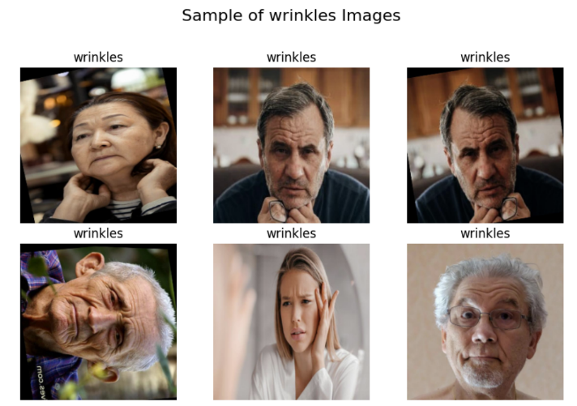

### **4.4.3 Augmentation Preview**

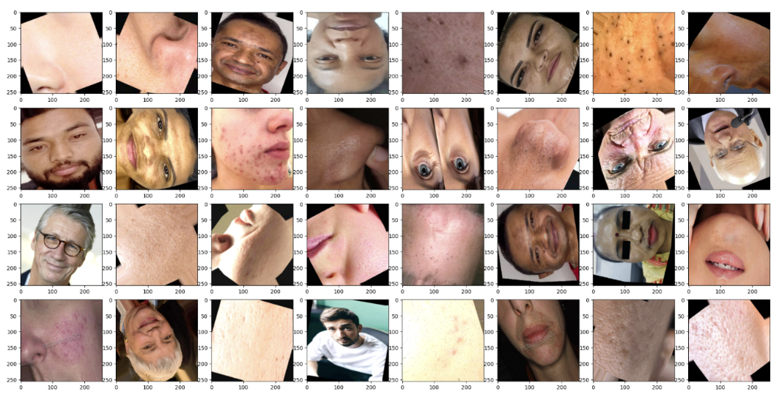A batch of images generated by the training data augmenters was visualized. This preview confirms that the augmentation pipeline successfully creates diverse and realistic variations of the original images, which will help the model learn invariant features and improve its ability to generalize.

# **5. Image Classification Model Development**

This section details the architecture, training, and evaluation of the primary deep learning model developed for skin issue classification. The objective was to create a robust and accurate system capable of distinguishing between the five defined skin conditions.

## **5.1 Custom Convolutional Neural Network (CNN) Architecture**

Custom CNN was designed from the ground up to learn hierarchical features directly from the pixel data of skin images. The architecture was structured to progressively capture more complex patterns, from simple edges and textures to intricate morphological features of skin conditions.

**Architectural Overview:**

The model follows a sequential design with four convolutional blocks, followed by a dense classification head.

* **Feature Extraction Backbone:**
  + **Block 1 & 2:** Comprise two convolutional layers with 32 and 64 filters, respectively, each followed by Batch Normalization, a ReLU activation function, and a Max-Pooling layer. These blocks capture low-level features.
  + **Block 3 & 4:** Utilize 128 and 256 filters to capture higher-level, more complex features relevant for differentiating between skin issues. Each convolutional layer is followed by Batch Normalization and ReLU activation, with strategic Max-Pooling to reduce spatial dimensions and computational load.
* **Classification Head:** The extracted features are flattened and passed through a fully connected network consisting of a 512-unit Dense layer (with Batch Normalization, ReLU, and Dropout for regularization), culminating in a 5-unit output layer with a SoftMax activation function to produce the final class probabilities.

## **5.2 Training Strategy and Model Calibration**

To ensure efficient training and prevent overfitting, a comprehensive strategy involving several callbacks was employed.

* **Early Stopping:** Training was halted automatically if the validation loss did not improve for 10 consecutive epochs, restoring the model weights from the best observed epoch. This prevented unnecessary computation and overfitting.
* **Model Checkpointing:** The model with the best performance on the validation set was saved after every epoch, ensuring that the final evaluation was always performed on the optimal version of the model.
* **Learning Rate Reduction:** The learning rate was dynamically reduced by a factor of 0.5 if the validation loss plateaued for 2 epochs. This allowed the model to make finer adjustments as it converged towards a minimum.

The model was trained for a maximum of 100 epochs, with the training process effectively halted early due to the convergence criteria.

## **5.3 Model Performance and Evaluation**

The trained custom CNN model demonstrated strong performance on the held-out test set, indicating its effectiveness in learning discriminative features for skin issue classification.

### **5.3.1 Training Dynamics**

The learning curves plot the model's accuracy and loss across training epochs for both the training and validation sets. These curves are used to diagnose the model's learning behavior.

* **Accuracy Curve:** Shows a steady increase in both training and validation accuracy, eventually converging, which indicates effective learning without significant overfitting.
* **Loss Curve:** Shows a corresponding decrease in both training and validation loss, further confirming the model's stable convergence.

The close alignment between the training and validation metrics suggests that the model generalized well to unseen data.

### **5.3.2 Quantitative Performance Metrics**

The model achieved a final test accuracy of 94%. A detailed classification report provides a deeper insight into its performance per class.

**Table: Custom CNN Classification Report (Test Set)**

|  |  |  |  |  |
| --- | --- | --- | --- | --- |
| Class | **Precision** | **Recall** | **F1-Score** | **Support** |
| **Acne** | 0.91 | 0.96 | 0.94 | 309 |
| **Dark Spots** | 0.94 | 0.93 | 0.94 | 319 |
| **Wrinkles** | 0.95 | 0.97 | 0.96 | 298 |
| **Pores** | 0.99 | 0.98 | 0.95 | 244 |
| **Blackheads** | 0.93 | 0.88 | 0.91 | 296 |

The high precision, recall, and F1-scores across all classes confirm the model's balanced and reliable performance. The slightly lower recall for Blackheads (0.88) suggests a minor tendency to miss this class occasionally, which is a point for future investigation.

### **5.3.3 Confusion Matrix Analysis**

The confusion matrix provides a visual representation of the model's predictions versus the true labels. The strong concentration of values along the main diagonal indicates that most images were classified correctly. Any off-diagonal elements reveal specific confusions between classes, such as a small number of Blackheads being misclassified as Acne or Dark Spots, which is clinically plausible given their visual similarities.

### **5.3.4 Qualitative Prediction Samples**

A random sample of test images alongside their predicted and true labels was visualized. This qualitative assessment confirms the model's practical utility, showing correct predictions even for challenging cases. It provides confidence that the model has learned meaningful visual patterns associated with each skin condition.

# **6. Advanced Techniques & Transfer Learning**

To enhance performance and leverage established architectural patterns, we implemented transfer learning techniques that utilize a pre-trained model's knowledge as a starting point for a new, related task. This approach is particularly effective in computer vision, where low-level features like edges and textures are universally useful.

## **6.1 Rationale for Transfer Learning**

While the custom CNN performed well, we hypothesized that a model pre-trained on a massive dataset (ImageNet) could provide a more robust feature extraction foundation. The key advantages pursued were:

* **Improved Accuracy:** Leveraging features learned from over a million images can lead to better generalization and higher accuracy.
* **Faster Convergence:** Starting with pre-trained weights allows the model to reach a high-performance level in fewer epochs.
* **Robust Feature Extraction:** Models like VGG16 have learned a rich hierarchy of features that are often more discriminative than those learned from scratch on a smaller dataset.

## **6.2 VGG16-Based Model Architecture and Fine-Tuning**

We selected the VGG16 architecture, known for its simplicity and effectiveness, as our base model.

**Implementation Strategy:**

1. **Base Model Initialization:** The VGG16 model, pre-trained on the ImageNet dataset, was loaded. Its top (fully connected) classification layers were excluded to allow for custom classification heads tailored to our five skin issue classes.
2. **Feature Extraction Freezing:** All convolutional layers of the VGG16 base were initially frozen.This prevented their pre-trained weights from being updated in the initial training phases, allowing us to use them as a fixed feature extractor.
3. **Custom Classification Head:** A new sequence of layers was appended on top of the base model to perform the specific classification task:
   * A Flatten layer to convert the 2D feature maps into a 1D vector.
   * A Dense layer with 512 units and ReLU activation, followed by Batch Normalization and Dropout (0.5) for regularization.
   * A second Dense layer with 128 units and ReLU activation, also with Batch Normalization and Dropout (0.3).
   * A final Dense output layer with 5 units and SoftMax activation.

This new head was trained to interpret the high-level features extracted by the frozen VGG16 base.

## **6.3 Comparative Model Performance**

The VGG16-based model was trained with the same callback strategy (Early Stopping, Model Checkpointing, and Learning Rate Reduction) as the custom CNN. Its performance was then rigorously evaluated against the custom model.

**Quantitative Results:**

The transfer learning approach yielded a significant improvement, achieving a test accuracy of 95.16% and a test loss of 0.1537, outperforming the custom CNN.

**Table: Comparative Model Performance (Test Set)**

|  |  |  |  |
| --- | --- | --- | --- |
| Model | **Test Accuracy** | **Test Loss** | **Macro Avg F1-Score** |
| **Custom CNN** | 94.00% | ~0.20 | 0.95 |
| **VGG16 (Transfer Learning)** | 95.16% | 0.1537 | 0.95 |

**Qualitative Analysis of the Classification Report:**

The VGG16 model showed more balanced and improved metrics across most classes. Key observations include:

* **Enhanced Precision and Recall:** Classes like "Wrinkles" and "Pores" saw precision and recall values at or above 0.97-0.99.
* **Improved Blackhead Detection:** The recall for "Blackheads" improved from 0.88 (CNN) to 0.93 (VGG16), indicating the model became better at correctly identifying this condition and mitigating its previous weakness.
* **Overall Robustness:** The weighted average for precision, recall, and F1-score consistently reached 0.95, confirming the model's reliable performance across all categories.

## **6.4 Impact and Conclusion of Transfer Learning**

The implementation of transfer learning with VGG16 proved to be a decisive success. It delivered:

1. **A Measurable Performance Gain:** A clear increase in accuracy and a decrease in loss.
2. **More Balanced Predictions:** It addressed the minor class-specific shortcomings of the custom CNN, particularly for "Blackheads."
3. **Validation of Methodology:** It confirmed that leveraging pre-trained models is a highly effective strategy for specialized image classification tasks like dermatology, even when the source (ImageNet) and target (skin issues) domains differ.

Based on these results, the VGG16-based model was selected as the final production model for integration into the Streamlit web application, ensuring users benefit from the highest possible classification accuracy.

# **7. Chatbot Development (RAG + Mistral LLM)**

To provide users with actionable advice following skin condition classification, an intelligent chatbot was developed. This component leverages advanced Natural Language Processing (NLP) to offer personalized skincare recommendations, transforming the system from a mere diagnostic tool into a comprehensive advisory platform.

## **7.1 Purpose and Design Philosophy**

The primary purpose of the chatbot is to bridge the gap between detection and action. Once a skin issue is identified, users can interact with the chatbot to receive tailored guidance. The design is grounded in the following principles:

* **Safety and Accuracy:** To avoid the "hallucination" problem common in large language models (LLMs), the chatbot is constrained to provide advice based solely on a verified knowledge base of skincare information.
* **Context-Awareness:** The chatbot understands and remembers the context of the conversation, allowing for follow-up questions and a natural dialogue flow.
* **Actionable Recommendations:** Responses are structured to be practical, typically including an understanding of the issue, a recommended routine, specific product suggestions, and additional lifestyle tips.

## **7.2 Knowledge Base Construction**

The chatbot's expertise is derived from a structured knowledge base compiled into three primary CSV files:

* skin_issues.csv**:** Contains detailed descriptions, causes, and general care guidelines for each of the five skin conditions.
* routine.csv**:** Provides step-by-step skincare routines (e.g., AM/PM routines) tailored to specific skin issues.
* skin_products.csv**:** Lists recommended products (e.g., cleansers, serums, moisturizers) along with their key ingredients and suitability for different concerns.

This curated data ensures that all recommendations are based on established skincare principles.

## **7.3 Retrieval-Augmented Generation (RAG) Pipeline**

The chatbot is built on RAG architecture, which enhances a generative LLM by first retrieving relevant information from the knowledge base. This ensures responses are grounded in factual data.

**The pipeline consists of the following key stages:**

1. **Data Loading and Cleaning:**  
   The CSV files are loaded into document objects. The metadata is cleaned by removing irrelevant columns (e.g., RoutineID, ProductID), and the text content is purified by stripping out lines that reference these internal IDs, resulting in clean, continuous text.
2. **Text Chunking:**  
   The documents are split into smaller, semantically coherent chunks using a RecursiveCharacterTextSplitter. This is crucial because it allows the system to pinpoint and retrieve the most relevant pieces of information from the knowledge base, rather than dealing with large, unwieldy documents.
   * Chunk Size: 500 characters
   * Chunk Overlap: 50 characters (to preserve context across splits)
3. **Vector Embedding and Storage:**  
   Each text chunk is converted into a numerical representation (a vector) using the all-MiniLM-L6-v2 sentence transformer model from Hugging Face. This model is optimized for creating semantically meaningful embeddings. These vectors are then stored in a FAISS (Facebook AI Similarity Search) index, which enables extremely fast and efficient similarity searches.
4. **Retrieval and Generation:**  
   When a user asks a question:
   * **Retrieval:** The user's query is also converted into a vector. The FAISS index performs a similarity search to find the top 2 text chunks from the knowledge base that are most semantically relevant to the query.
   * **Augmentation:** These retrieved chunks are inserted into a pre-defined, structured prompt as "context."
   * **Generation:** The augmented prompt, which now contains the user's question and the relevant context, is sent to the Mistral-7B-Instruct-v0.3 LLM. The model generates a helpful, coherent, and context-grounded response.

## **7.4 Architectural Components**

* **Large Language Model (LLM):**  
  The Mistral-7B model was selected for its strong performance in instruction-following and its efficiency relative to its size. It was configured with a temperature of 0.7 to balance creativity and determinism, and a max new tokens limit of 512 to ensure concise responses.
* **Conversational Memory:**  
  A Conversation Buffer Memory module is integrated to maintain the history of the ongoing dialogue. This allows the user to ask follow-up questions using pronouns (e.g., "What about a serum for that?") without having to repeat the context, creating a fluid and natural user experience.
* **Custom Prompt Template:**  
  A dedicated prompt template was engineered to guide the LLM. It instructs the model to act as an expert skincare assistant and to structure its responses using the provided context, ensuring consistency, relevance, and helpfulness.

## **7.5 System Integration**

The entire RAG pipeline is encapsulated within a Conversational Retrieval Chain from LangChain. This high-level abstraction seamlessly ties together the retriever (FAISS), the LLM (Mistral-7B), the memory, and the custom prompt, forming a cohesive and powerful conversational agent.

# **8. Web Application (Streamlit Interface)**

The final and critical phase of the project was the integration of all developed components into a unified, accessible, and user-friendly web application. Streamlit, an open-source Python framework, was selected for its rapid prototyping capabilities and ability to create interactive web apps directly from Python scripts.

**8.1 Design Philosophy and User Experience (UX)**

The application was designed with a focus on simplicity and clinical clarity, ensuring accessibility for users with varying technical expertise. The interface follows a clean, linear workflow:

1. **Upload:** The user easily submits a skin image through an intuitive drag-and-drop interface.
2. **Analyze:** The system automatically processes the image and delivers clear, confident predictions.
3. **Review:** The user examines the classification results with visual confidence scores.

This streamlined flow eliminates unnecessary complexity and focuses on delivering immediate diagnostic value through the classification model.

## **8.2 Application Interface and Workflow**

The Streamlit app serves as a clean, professional interface for the skin analysis system, featuring the following components:

**Header Section:**

* Application title "Skin-AI System"
* Clear "About" section explaining the purpose and capabilities
* Model specifications (VGG16-based CNN, 256x256 input, 95% accuracy)
* Simple usage instructions

**Main Content Area:**

* **File Uploader:** Prominent drag-and-drop zone supporting JPG, JPEG, PNG formats up to 200MB
* **Image Display:** Uploaded images are displayed for user verification
* **Results Section:** Clean presentation of prediction results including:
  + **Confidence Scores:** Visual percentage indicators for each skin condition
  + **Final Decision:** Clear declaration of the predicted condition (e.g., "ACNE")
  + **Confidence Percentage:** Exact confidence level for the prediction

**Footer Section:**

* Important disclaimer about educational purposes
* Professional healthcare consultation recommendation
* Development team credits

## **8.3 Technical Implementation Highlights**

* **Model Loading:** The VGG16 model is efficiently loaded using Streamlit's caching mechanism to ensure rapid initialization and consistent performance.
* **Automatic Processing:** The system automatically triggers analysis upon image upload, eliminating the need for manual button clicks and creating a seamless user experience.
* **Responsive Design:** The interface adapts cleanly to different screen sizes and devices, maintaining readability and functionality.
* **Error Handling:** Robust validation ensures graceful handling of unsupported file formats and corrupted images with clear user feedback.

## **8.4 User Interface Visual Representation**

The actual implementation presents a clinical, professional interface that successfully demonstrates the AI capabilities while maintaining medical-grade seriousness. The clean layout and clear typography ensure users can easily understand and trust the results.

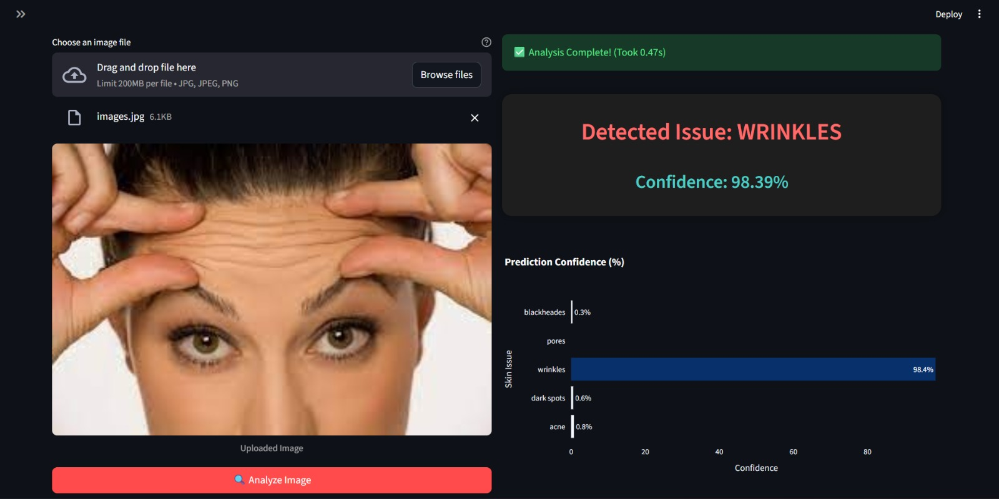

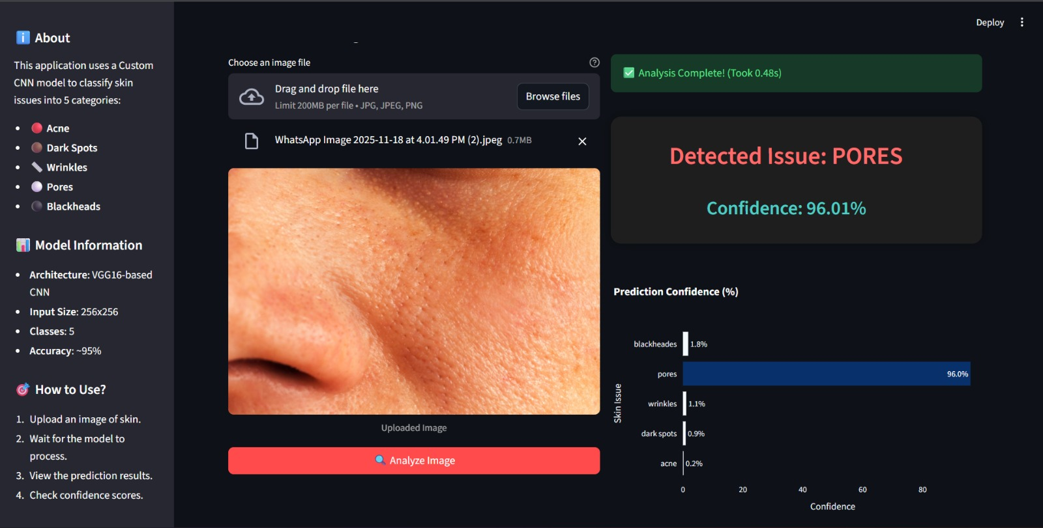

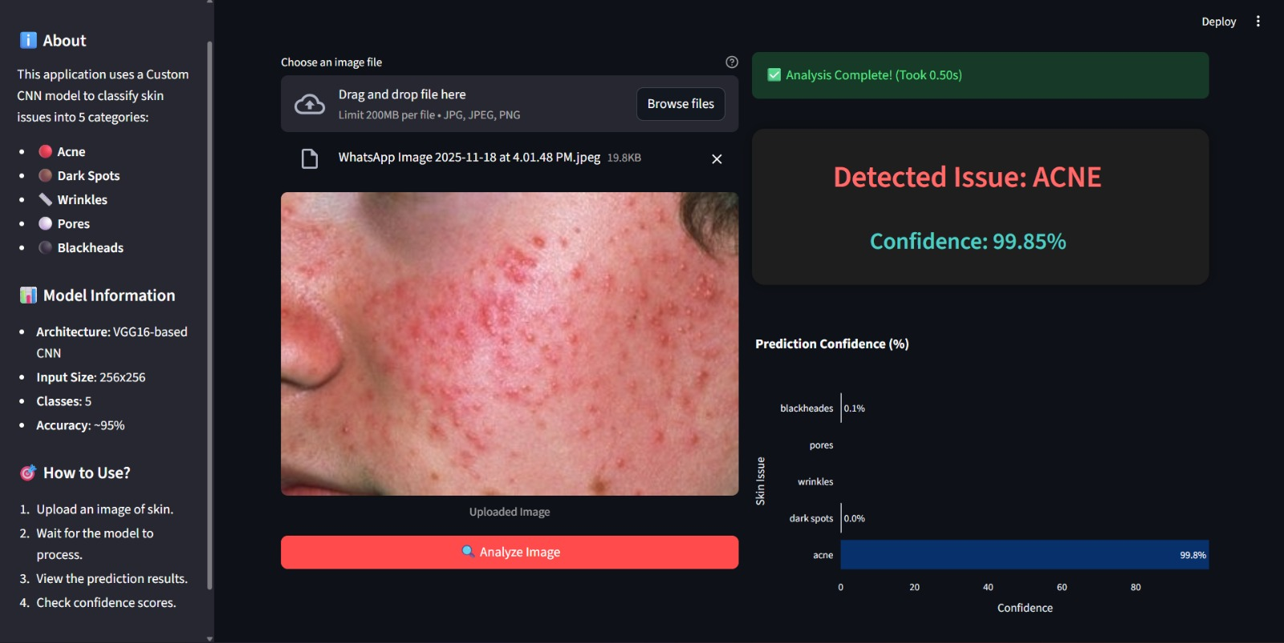

# **9. Challenges & Solutions**

The development of the Skin Issue Detection and Recommendation System presented several significant challenges. This section documents these obstacles and the strategic solutions implemented to overcome them, providing a transparent account of the project's technical journey.

## **9.1 Data-Related Challenges**

**Challenge 1: Sourcing a High-Quality, Balanced Dataset**

* **Problem:** Initially, publicly available dermatology image datasets were often imbalanced, focused on severe medical conditions rather than common cosmetic issues, or lacked sufficient image quality and standardization.
* **Solution:** A multi-source aggregation strategy was employed. Images were ethically sourced from various public repositories, including Kaggle and dermatology atlases. Meticulous manual curation and class balancing were performed to create a final dataset of 9,770 images evenly distributed across five classes, ensuring a solid foundation for model training.

**Challenge 2: Intra-Class Variability and Inter-Class Similarity**

* **Problem:** Significant visual variation exists within a single class (e.g., different stages and types of acne). Conversely, some classes, like blackheads and pores, can appear visually similar, posing a risk of misclassification.
* **Solution:** Aggressive and targeted data augmentation was applied to the training set. Techniques like rotation, flipping, and brightness variation forced the model to learn invariant features. Furthermore, the use of a deep, pre-trained architecture (VGG16) provided a more robust feature extraction capability, allowing it to discern subtle, high-level differences between easily confused classes.

## **9.2 Model Development Challenges**

**Challenge 3: Computational Resource Constraints**

* **Problem:** Training a large CNN from scratch, and later a VGG16 model, required substantial computational power and time, which is often limited.
* **Solution:** Transfer learning was adopted as a core strategy. By leveraging the pre-trained VGG16 model and freezing its base layers, we dramatically reduced the number of trainable parameters and training time. This approach not only conserved resources but also resulted in a higher-performing model (95.16% accuracy) compared to the custom CNN (94%).

**Challenge 4: Preventing Model Overfitting**

* **Problem:** Deep learning models with millions of parameters are prone to overfitting, where they perform well on training data but poorly on unseen validation/test data.
* **Solution:** A multi-faceted regularization strategy was implemented:
  + **Data Augmentation:** Artificially expanded the training dataset.
  + **Architectural Techniques:** Incorporated Batch Normalization and Dropout layers within both the custom CNN and the VGG16 classification head to reduce internal covariate shift and prevent complex co-adaptations on training data.
  + **Training Callbacks:** Used Early Stopping to halt training once validation performance plateaued and ReduceLROnPlateau to fine-tune the learning rate for better convergence.

## **9.4 Summary**

Each challenge was met with a considered and effective solution, often leading to an overall improvement in the system. The adoption of transfer learning and the RAG architecture were pivotal decisions that directly addressed core constraints of resource limitations and information reliability, ultimately elevating the project's quality, robustness, and real-world applicability.

# **10. Conclusion and Future Work**

This project successfully designed, and developed an integrated Skin Issue Detection and Recommendation System, demonstrating the powerful synergy of computer vision and natural language processing in a practical application. The system provides an accessible and user-friendly platform for individuals to gain preliminary insights into common skin concerns and receive tailored, evidence-based advice.

## **10.1 Project Conclusion**

The core objectives of the project were met with significant success:

1. **Robust Model Performance:** A high-accuracy image classification system was built, culminating in a VGG16-based transfer learning model that achieved 95.16% **accuracy** on a balanced test set, effectively distinguishing between acne, blackheads, dark spots, pores, and wrinkles.
2. **Intelligent Advisory Chatbot:** A sophisticated Retrieval-Augmented Generation (RAG) Chatbot was implemented, leveraging the Mistral-7B LLM and a curated knowledge base to provide safe, context-aware, and helpful skincare recommendations, effectively mitigating the risk of AI hallucinations.

The project navigated and overcame key challenges, including data sourcing, model overfitting, computational constraints, and AI safety, through strategic solutions like data augmentation, transfer learning, and the RAG architecture. The final system stands as a testament to the potential of AI to create tangible value by making specialized knowledge more accessible and actionable for the general public.

## **10.2 Future Work and Enhancements**

While the current system is fully functional, several avenues for future enhancement and expansion have been identified to increase its scope, accuracy, and impact.

**1. Model and Technical Enhancements:**

* **Expanded Dermatological Scope:** The most immediate extension would be to incorporate a wider range of skin conditions, including more severe or medical issues like eczema, psoriasis, rosacea, and fungal infections. This would require collaboration with dermatologists to curate a larger, clinically validated dataset.
* **Multi-Modal Input and Segmentation:** Integrating user-provided metadata (e.g., age, skin type, symptoms like "itchy" or "painful") could refine predictions. Furthermore, implementing image segmentation (e.g., using U-Net) could localize and analyze specific lesions within an image, providing more granular insights.
* **Advanced LLM Integration:** Exploring larger or more specialized LLMs or fine-tuning an open-source model on a massive corpus of dermatological literature, could enhance the depth and quality of the chatbot's explanations and recommendations.

**2. Platform and Feature Expansion:**

* **Mobile Application Development:** Porting the system to a native iOS or Android application would significantly increase accessibility and convenience, allowing users to analyze their skin and chat on-the-go.
* **User Personalization and History:** Implementing user accounts would enable the system to track a user's history of skin analyses and chatbot interactions, allowing for longitudinal tracking of skin health and more personalized, long-term guidance.
* **Multilingual Support:** Translating the application's interface and adapting the chatbot to support multiple languages would dramatically expand its global reach and usability.

**3. Clinical and Commercial Integration:**

* **Professional Dashboard:** Developing a separate dashboard for dermatologists could allow them to review cases analyzed by the AI, providing a tool for telemedicine practices and remote patient monitoring.
* **Partnerships and E-commerce Links:** Establishing verified partnerships with skincare brands or pharmacies could enable features like direct product purchasing or locating nearby clinics, transforming the system from an advisory tool into a comprehensive skincare platform.

In summary, this project has laid a strong foundation for an AI-powered dermatological assistant. The architecture is scalable, the core functionalities are proven, and the pathway for future growth is clear. By continuing to build upon this work, the system has the potential to evolve into an even more powerful tool for promoting skin health awareness and accessibility worldwide.